CLEAR Social Justice Leadership
Mentoring Program

Protégé Application Packet

Application Check List:
- Protégé Application
- Supplement to Application
- Resume
- Letters of Recommendation
All applicants are required to submit two letters of recommendation with their application. Letters of recommendation may come from someone who has worked with you in a professional setting, community or volunteer colleagues, college faculty and/or other personal references (not including relatives). Please request that all recommendation letters be on letterhead.
Please e-mail all of the above mentioned to jbaquera@clearvoz.com

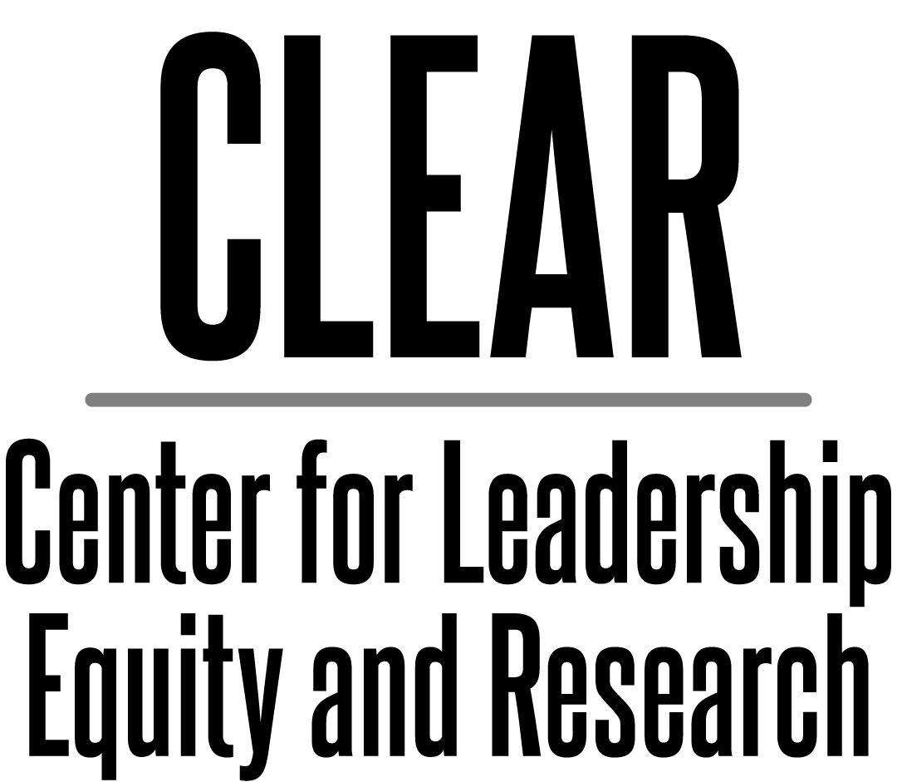
CLEAR
E-mail: jbaquera@clearvoz.com
www.clearvoz.com

Hello,

You are receiving this because you have expressed an interest in participating in the CLEAR Social Justice Leadership Mentoring Program as either a mentor or protégé. The goals of this program are fourfold:

- To provide leadership and mentoring opportunities whereby leaders understand that they are not alone in their commitment to social justice leadership and that they will be supported by program participants, past and present

- To develop positive role models for students from underserved communities and for other at-risk populations

- To develop social justice leaders who are committed to equity practices and intentional activism (praxis)

- To provide leadership learning opportunities in the areas of:
  - Mentoring
  - Systemic Change
  - Networking
  - Social Justice Advocacy
  - Cultural and Intercultural Communication
  - Intentional Activism – Praxis
- Or any subject area chosen by the cohort

It is very important that social justice leaders understand that at the Center for Leadership, Equity, and Research we intentionally define the difference between “diversity” and “equity.” Using a definition I developed, the main difference between the two is that “diversity gives us a place at the table while equity gives us a voice at the table.” Having “voice” is critically important to those of us engaged in this work…for by using our voice and supporting each other, we can and will continue to impact change in the system.

I look forward to receiving your application and additional materials.

Keep the faith,

Kenneth Magdaleno, Ed. D.
Founder/CEO/President

Mission
The Center for Leadership, Equity, and Research (CLEAR) is dedicated to eliminating educational and social disparities which impede equitable opportunities and outcomes for all students and the communities from which they arrive. This includes advocacy by its leadership which is called upon to intentionally amplify a collective voice of educational leaders and allies through a forum of professional learning, political action, and community empowerment.

Founder/ CEO/ President
Kenneth Magdaleno, Ed.D.

Director Leadership Division
Beatriz Chaidez, Ed.D.

Program Manager
Jenny Baquera

What We Do

Equity
CLEAR intends to serve as a catalyst for social transformation. Our efforts in the area of equity include training educational and community leaders to ensure that underrepresented groups have “voice” when addressing issues of social change. We accomplish this through:
      - Advocacy in the area of social-emotional learning
- Community Empowerment
- Professional Development in the area of Cultural Proficiency
- Equity in Action

Leadership
We provide leadership in the following areas.
- Mentoring educational and community leaders through the CLEAR Social Justice Leadership Mentoring Program
- Sponsoring and Supporting the CLEAR Young Professionals Cohort (CYPC)

Research
We endorse, promote, and publish Journal of Leadership, Equity, and Research (JLER) with promising research in the following areas.
- Educational reform in PreK-12 and higher education
- Social Justice Leadership and leadership mentoring
- Intersections of diversity and access to educational resources
- Social justice around important and timely issues of access to resources

Copyright © 2012 CLEAR
All rights reserved. No portion of this work may be copied, or sold or used for any commercial advantage or private gain, nor any derivative work prepared there from, without the express prior written permission of CLEAR through its Board of Directors.

The Center for Leadership, Equity, and Research (CLEAR) Social Justice Leadership Mentoring Program provides participants with an opportunity to participate in a formal and structured mentoring program. Mentors and protégés work together to develop goals and objectives that guide each towards a more meaningful social justice leadership experience whereby participants combine professional learning and mentoring to succeed as a leader. The CLEAR Social Justice Leadership Mentoring Program develops a “mentoring culture” whereby mentors and protégés, together with other like-minded leaders, seize upon the opportunity to implement and participate in "Praxis" or "Intentional Activism," meant to change the manner in which "things have always been done."

The program includes:
- Mentorship Training
- Social Justice Leadership Training and Seminars
- Guest Speakers from the Education, Legal, and Political Realms

CLEAR Social Justice Leadership Mentoring Program Phase 1 - 4:
Leadership Seminars (all meetings will be virtual)

PHASE I
September - November
- Social Justice and Social Justice Mentoring
- Social Justice and Systemic Change
- Intentional Activism – Praxis

PHASE II
December – February
- The importance of leadership networking
- Social Justice Advocacy

PHASE III
March – April
- Cultural Proficiency
- Intercultural Communication

PHASE IV
May – June
- Year One Final Stage: Completion, evaluation, and celebration in recognition of year one

Expectations are that the applicant/protégé will:
- Be open to learn and apply the traits identified as those of a successful social justice leader by the Center of Leadership, Equity and Research (CLEAR).
- Pay $200 yearly membership contribution to the CLEAR Social Justice Leadership Mentoring Program.
- Attend quarterly meetings at scheduled times and places designated by CLEAR leadership (until further notice meetings will be online).
- Attend two mandatory CLEAR conferences (Equity Institute & Social Justice Summit). Dates to be determined.
- Contribute to leadership learning and development.
- Contribute to networking of the cohort.
- Support each other as is expected from a cohort model.

Location:
Virtual

Mentor and Protégé Orientation
Tuesday, October 6, 2020
6:00 p.m. – 8:00 p.m.

Meeting 1
Saturday, November 21, 2020
9:00 a.m. – 1:00 p.m.
May be replaced by Equity Institute

Meeting 2
Saturday, February 20, 2021
9:00 a.m. – 1:00 p.m.

CLEAR Summit
TBD

Meeting 4
Saturday, April 17, 2021
9:00 a.m. – 1:00 p.m.

End of Year Celebration
Saturday, June 5, 2021
12:00 p.m. – 3:00 p.m.

CLEAR Social Justice Leadership
Mentoring Program
Protégé Application
Welcome to the CLEAR Social Justice Leadership Mentoring Program. In addition to completing this application, please submit a current resume or curriculum vitae. Limit the document to two pages.
Name:
Address:
Current Position
Organization
Phone:
Fax:
Mobile:
E-mail Address:

Program requirements
- CLEAR membership is required of participants.
- Mentor and protégé pairs should meet monthly at a site to be determined by the two of them.
- Mentors and protégés are expected to make bi‐weekly contacts at a minimum; Face-to-face meetings are preferred. However, e-mails, phone meetings, and the use of social media may also be used.
- At some stage in the relationship the mentor should offer to do the following: instruct, guide, counsel, support, role model, validate, motivate, communicate, tutor and mentor the protégé. The mentor should have the ability and knowledge to choose the most appropriate role necessary at the time.

As a Protégé participant in the CLEAR Social Justice Leadership Mentoring Program, I agree to all the conditions listed above.

Signature Date

CLEAR Social Justice Leadership
Mentoring Program
Supplement to Application
When selected for the CLEAR Social Justice Leadership Mentoring Program, protégés gain access to professional mentoring, development of their current leadership skills, and the opportunity to network in their chosen area of interest.

Name: Date:

Profession and Title:

What significant personal/and or professional factors have most informed your present leadership outlook? How does this impact your relationship to your community and your approach to Educational Equity and Social Justice leadership?

What leadership skills and experiences do you desire to gain? How might a mentor be most helpful to you?

