CLEAR Social Justice Leadership
Mentoring Program

Mentor Application Packet

Application Check List:
- Mentor Application
- Supplement to Application
- Resume

Please e-mail all of the above mentioned to kmagdaleno@clearvoz.com
CLEAR
E-mail: kmagdaleno@clearvoz.com
www.clearvoz.com

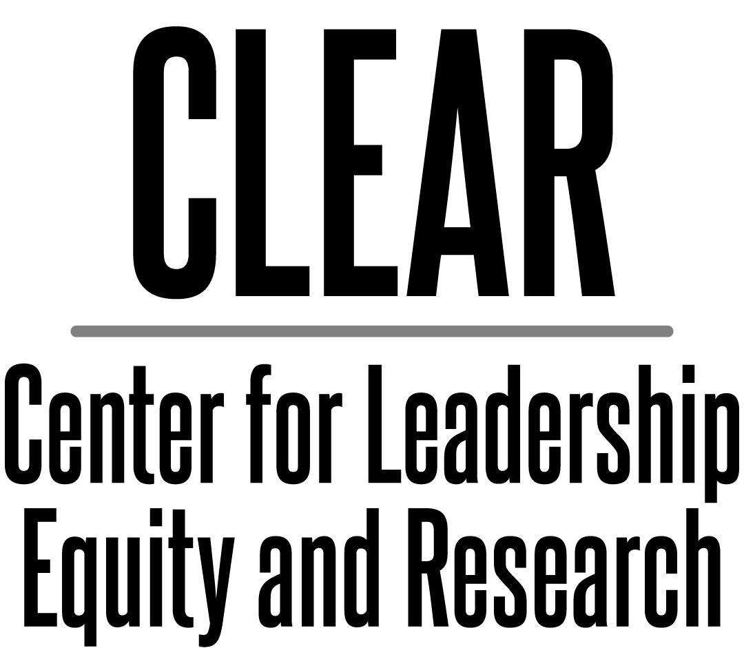

Good Day,

You are receiving this because you have expressed an interest in participating in the CLEAR Social Justice Leadership Mentoring Program as either a mentor or protégé. The goals of this program are fourfold:

- To provide leadership and mentoring opportunities whereby leaders understand that they are not alone in their commitment to social justice leadership and that they will be supported by program participants, past and present

- To develop positive role models for students from underserved communities and for other at-risk populations

- To develop social justice leaders who are committed to equity practices and intentional activism (praxis)

- To provide leadership learning opportunities in the areas of:
  - Mentoring
  - Systemic Change
  - Networking
  - Social Justice Advocacy
  - Cultural and Intercultural Communication
  - Intentional Activism – Praxis

It is of great importance that social justice leaders understand that at the Center for Leadership, Equity, and Research we intentionally define the difference between “diversity” and “equity.” Using a definition I developed, the main difference between the two is that “diversity gives us a place at the table while equity gives us a voice at the table.” Having “voice” is critically important to those of us engaged in this work…for by using our voice and supporting each other, we can and will continue to impact change in the system.

I look forward to receiving your application and additional materials.

Keep the faith,

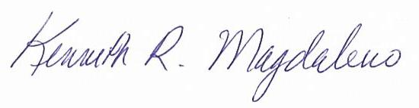
Kenneth Magdaleno, Ed. D.
Founder/CEO

Mission
The Center for Leadership, Equity, and Research (CLEAR) is dedicated to eliminating educational and social disparities which impede equitable opportunities and outcomes for all students and the communities from which they arrive. This includes advocacy by its leadership which is called upon to intentionally amplify a collective voice of educational leaders and allies through a forum of professional learning, political action, and community empowerment.

Founder/ CEO
Kenneth Magdaleno, Ed.D.

Program Manager
Jenny Baquera

CLEAR Budget Coordinator and
Leadership Assistant
Valerie Kelly

What We Do

Equity
CLEAR intends to serve as a catalyst for social transformation. Our efforts in the area of equity include training educational and community leaders in order to ensure that underrepresented groups have “voice” when addressing issues of social change. We accomplish this through:
      - Advocacy
- Community Empowerment
- Professional Development in the area of Action Oriented Leadership
- Equity in Action

Leadership
We provide leadership in the following areas.
- Mentoring educational and community leaders through the CLEAR Leadership Mentoring Program
- Sponsoring and Supporting the CLEAR Young Professionals Cohort (CYPC)

Research
We endorse, promote, and publish (CLEARVoz Journal) promising research in the following areas.
- Educational reform in PreK-12 and higher education
- Leadership and leadership mentoring
- Intersections of diversity and access to educational resources
- Social justice around important and timely issues of access to resources

Copyright © 2012 CLEAR
All rights reserved. No portion of this work may be copied, or sold or used for any commercial advantage or private gain, nor any derivative work prepared there from, without the express prior written permission of CLEAR through its Board of Directors.

The Center for Leadership, Equity, and Research (CLEAR) Social Justice Leadership Mentoring Program provides participants with an opportunity to participate in a formal and structured mentoring program. Mentors and protégés work together to develop goals and objectives that guide each towards a more meaningful leadership experience whereby participants combine professional learning and mentoring to succeed as a leader. The CLEAR Social Justice Leadership Mentoring Program develops a “mentoring culture” whereby mentors and protégés, together with other like-minded leaders, seize upon the opportunity to implement and participate in "Praxis" or "Intentional Activism," meant to change the manner in which "things have always been done."

The program includes:
- Mentorship Training
- Leadership Training and Seminars
- Guest Speakers from the Education, Legal, and Political Realms

CLEAR Leadership Mentoring Program Phase 1 - 4:
Leadership Seminars

PHASE I
September - November
What is a Formal Mentoring Program? Developing a Mentoring framework/Clarifying common interests / Setting goals and objectives. Attend CLEAR Leadership Mentoring Summit.

PHASE II
December - February
Communication: Learning to listen, share, and confide in one another. Comparing values and expressing personal concerns. Networking

PHASE III
March - April
Mentoring in Organizations: Solving complex professional and social problems in the protégés career

PHASE IV
May - June
Year One Final Stage: Completion, evaluation, and celebration in recognition of year one

Expectations are that the applicant will:
- Be open to learn and apply the traits identified as those of a successful leader by the Center of Leadership, Equity and Research (CLEAR)
- Pay $250 yearly membership contribution to the CLEAR Social Justice Leadership Mentoring Program
- Attend quarterly meetings at scheduled times and places designated by CLEAR leadership
- Attend two mandatory CLEAR conferences to be determined
- Contribute to leadership development and networking of the cohort
- Support each other as is expected from a cohort model

Location:  Fresno, Calif. | Continental Breakfast and Lunch provided for each meeting.

Mentor and Protégé Orientation
Saturday, August 10, 2019
9:00 a.m. – 1:00 p.m.

Meeting 1
Saturday, November 9, 2019
9:00 a.m. – 1:00 p.m.

Meeting 2
Saturday, February 8, 2020
9:00 a.m. – 1:00 p.m.

CLEAR Summit
March 2020

Meeting 4
Saturday, April 11, 2020
9:00 a.m. – 1:00 p.m.

End of Year Celebration
Saturday, June 18, 2020
12:00 p.m. – 3:00 p.m.

CLEAR Social Justice Leadership
Mentoring Program
Mentor Application
Welcome to the CLEAR Social Justice Leadership Mentoring Program. In addition to completing this application, please submit a current resume or curriculum vitae. Limit the document to two pages.

Name:
Address:
Title
Company
Phone:
Fax:
Mobile:
E-mail Address:

Program Conditions
- CLEAR membership is required of participants.
- Mentor and protégé pairs should meet monthly at a site to be determined by the two of them.
- Mentors and protégés are expected to make bi‐weekly contacts at a minimum; Face-to-face meetings are preferred. However, e-mails, phone meetings, and the use of social media may also be used.
- At some stage in the relationship the mentor should offer to do the following: instruct, guide, counsel, support, role model, validate, motivate, communicate, tutor and mentor the protégé. The mentor should have the ability and knowledge to choose the most appropriate role necessary at the time.

As a Mentor participant in the CLEAR Social Justice Leadership Mentoring Program, I agree to all the conditions listed above.

Signature Date

CLEAR Social Justice Leadership
Mentoring Program
Supplement to Application
Name: Date:

1) Why do you want to become a mentor?

2) What do you feel are the leadership strengths you can bring to this program?

3) Write a brief statement on why you would choose to participate in the mentor program.

4) If agreed, please initial the two statements below:

_____ I understand that the mentoring program involves communicating in some form with my protégé at least every two weeks for the first year of the program

_____ I understand that I will be required to complete the mentor program orientation and at least two training sessions during the year.

5. Please list two references (One personal and one professional)

Name:
Address:
Phone
Relationship

Name:
Address:
Phone
Relationship

