CLEAR Leadership
Mentoring Program

Supported by:

Protégé Application Packet
Application Check List:
- Protégé Application
- Supplement to Application
- Resume
- Letters of Recommendation
All applicants are required to submit two letters of recommendation with their application. Letters of recommendation may come from someone who has worked with you in a professional setting, community or volunteer colleagues, college faculty and/or other personal references (not including relatives). Please request that all recommendation letters be on letterhead.
Please e-mail all of the above mentioned to kmagdaleno@clearvoz.com
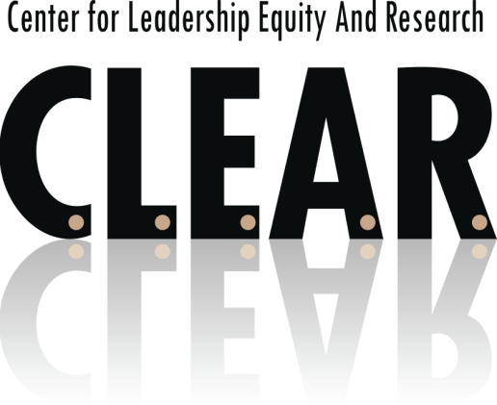
Applications are due by May 29, 2017
CLEAR
E-mail: kmagdaleno@clearvoz.com
www.clearvoz.com

Hello,

You are receiving this because you have expressed an interest in becoming a protégé in the CLEAR Leadership Mentoring Program. The goals of this program are fourfold:

- To provide mentoring opportunities whereby leaders understand that they are not alone in their commitment to Educational Leadership and will be supported by the program, their mentor and the remainder of the cohort

- To develop positive role models for students from underserved communities and for other at-risk populations

- To develop leaders who are committed to educational equity practices and praxis

- To provide leadership learning opportunities in the areas of:

  - Mentoring
  - Systemic Change
  - Networking
  - Advocacy
  - Cultural and Intercultural Communication
  - Intentional Activism – Praxis

What are educational equity practices? Over the last few years I have made sure that leaders involved with CLEAR understand the difference between diversity and equity. Although both are very important areas, the main difference between the two is that “diversity gives us a place at the table while equity gives us a voice at the table.”

Having “voice” is critically important to those of us engaged in the work…and it will continue to be very important to those involved in the CLEAR Leadership Mentoring Program.

I look forward to receiving your application and additional materials.

Best,

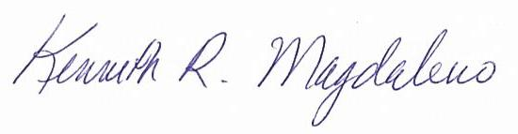
Kenneth Magdaleno, Ed. D.
Executive Director

Mission
The Center for Leadership, Equity, and Research (CLEAR) is dedicated to eliminating educational and social disparities which impede equitable opportunities and outcomes for all students and the communities from which they arrive. This includes advocacy by its leadership which is called upon to intentionally amplify a collective voice of educational leaders and allies through a forum of professional learning, political action, and community empowerment.

Supported By
Our Leadership Mentoring Program is supported by a grant through The California Endowment. The mission of The California Endowment is to expand access to affordable, quality health care for underserved individuals and communities and to promote fundamental improvements in the health status of all Californians.

Executive Director
Kenneth Magdaleno, Ed.D.

Program Coordinator
Jenny Vue

Executive Assistant
Tiffany Jennings

What We Do

Equity
CLEAR intends to serve as a catalyst for social transformation. Our efforts in the area of equity include training educational and community leaders in order to ensure that underrepresented groups have “voice” when addressing issues of social change. We accomplish this through:
      - Advocacy in the area of social-emotional learning
- Community Empowerment
- Professional Development in the area of Action Oriented Leadership
- Equity in Action

Leadership
We provide leadership in the following areas.
- Mentoring educational and community leaders through the CLEAR Leadership Mentoring Program
- Supporting Youth Mentoring Programs

Research
We endorse, promote, and publish (CLEARVoz Journal) promising research in the following areas.
- Educational reform in PreK-12 and higher education
- Leadership and leadership mentoring
- Intersections of diversity and access to educational resources
- Social justice around important and timely issues of access to resources
- Technology in education

Copyright © 2012 CLEAR
All rights reserved. No portion of this work may be copied, or sold or used for any commercial advantage or private gain, nor any derivative work prepared there from, without the express prior written permission of CLEAR through its Board of Directors.

The Center for Leadership, Equity, and Research (CLEAR) Leadership Mentoring Program provides participants with an opportunity to participate in a formal and structured mentoring program. Mentors and protégés work together to develop goals and objectives that guide each towards a more meaningful leadership experience whereby participants combine professional learning and mentoring to succeed as a leader. The CLEAR Leadership Mentoring Program develops a “mentoring culture” whereby mentors and protégés, together with other like-minded leaders, seize upon the opportunity to implement and participate in "Praxis" or "Intentional Activism," meant to change the manner in which "things have always been done."

The program includes:
- Mentorship Training
- Leadership Training and Seminars
- Guest Speakers from the Education, Legal, and Political Realms

CLEAR Leadership Mentoring Program Phase 1 - 4:
Leadership Seminars

PHASE I
July - November
What is a Formal Mentoring Program? Developing a Mentoring
framework/Clarifying common interests / Setting goals and objectives. Attend CLEAR Mentoring Summit.

PHASE II
December - February
Communication: Learning to listen, share, and confide in one another. Comparing values and expressing personal concerns. Networking

PHASE III
March-May
Mentoring in Organizations: Solving complex professional and social problems in the protégés career

PHASE IV
June-July
Year One Final Stage: Completion, evaluation, and celebration in recognition of year one

Expectations are that the applicant will:
- Be open to learn and apply the traits identified as those of a successful leader by the Center of Leadership, Equity and Research (CLEAR)
- Pay $100 yearly membership contribution to the CLEAR Leadership Mentoring Program
- Attend the August 2017 interview in Fresno before CLEAR board members and sponsors
- Attend quarterly meetings at scheduled times and places designated by CLEAR leadership
- Attend two mandatory conferences including:
CLEAR Mentoring Summit on October 27, 2017 and one additional CLEAR selected Conference in California (registration will be paid by CLEAR)
- Contribute to leadership development and networking of the cohort
- Support each other as is expected from a cohort model

Location:  Fresno, Calif. | Continental Breakfast and Lunch provided for each meeting.

Mentor and Protégé Orientation
Saturday, September 30, 2017
10:00 a.m. – 1:00 p.m.

Meeting 1
Friday, October 27, 2017
CLEAR Mentoring Summit – California State University, Fresno
North Gym 118

Meeting 2
Saturday, December 2, 2017
9:00 a.m. – 1:00 p.m.

Meeting 3
Saturday, February 24, 2018
9:00 a.m. – 1:00 p.m.

Meeting 4
Saturday, April 28, 2018
9:00 a.m. – 1:00 p.m.

End of Year Celebration
Thursday, June 21, 2018
6:00 p.m.

CLEAR Leadership Mentoring Program
Protégé Application
Welcome to the CLEAR Leadership Mentoring Program. In addition to completing this application, please submit a current resume or curriculum vitae. Limit the document to two pages.

Name:
Address:
Current Position
Current District
Phone:
Fax:
Mobile:
E-mail Address:

Program Conditions
- CLEAR membership is required of participants.
- Mentor and protégé pairs should meet monthly at a site to be determined by the two of them.
- Mentors and protégés are expected to make bi‐weekly contacts at a minimum; Face-to-face meetings are preferred. However, e-mails, phone meetings, and the use of social media may also be used.
- At some stage in the relationship the mentor should offer to do the following: instruct, guide, counsel, support, role model, validate, motivate, communicate, tutor and mentor the protégé. The mentor should have the ability and knowledge to choose the most appropriate role necessary at the time.

As a Protégé participant in the CLEAR Leadership Mentoring Program, I agree to all the conditions listed above.

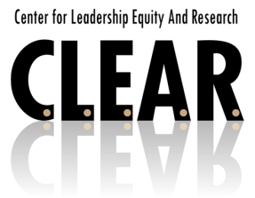
Signature Date

CLEAR Leadership Mentoring Program
Supplement to Application
When selected for the CLEAR Leadership Mentoring Program, protégés gain access to professional mentoring, development of their current leadership skills, and the opportunity to network in their chosen area of interest.

Name: Date:

Profession and Title:

What significant personal/and or professional factors have most informed your present leadership outlook? How does this impact your relationship to your community and your approach to Educational Equity and Social Justice leadership?

What leadership skills and experiences do you desire to gain? How might a mentor be most helpful to you?

